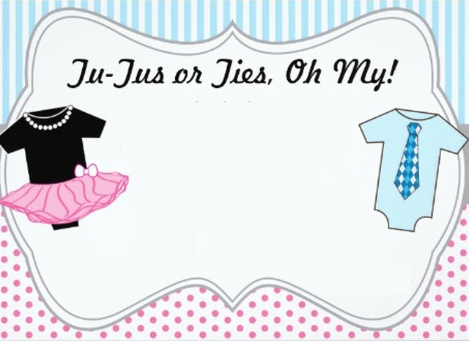

Join us for a gender reveal shower for __________.

Saturday, May 1st at 3pm

1234 Main Street,

Anytown, CA

Pink or blue?

RSVP by April 15.

If choosing a gift is not your cup of tea,

check the registry at The Baby Store.