Expiring card email template

Hi Jared,We wanted to let you know that your card is expiring soon.
You can access your free online giving account through our donor portal. From there, you’ll be able to update your email and billing preferences, keep track of your donations, and make donating to the Sea Turtle Foundation event easier.
Thank you for your support!
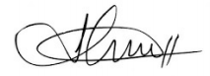
Jonathan
The Sea Turtle Foundation

