Sample Letter 1: Long Version

Template:
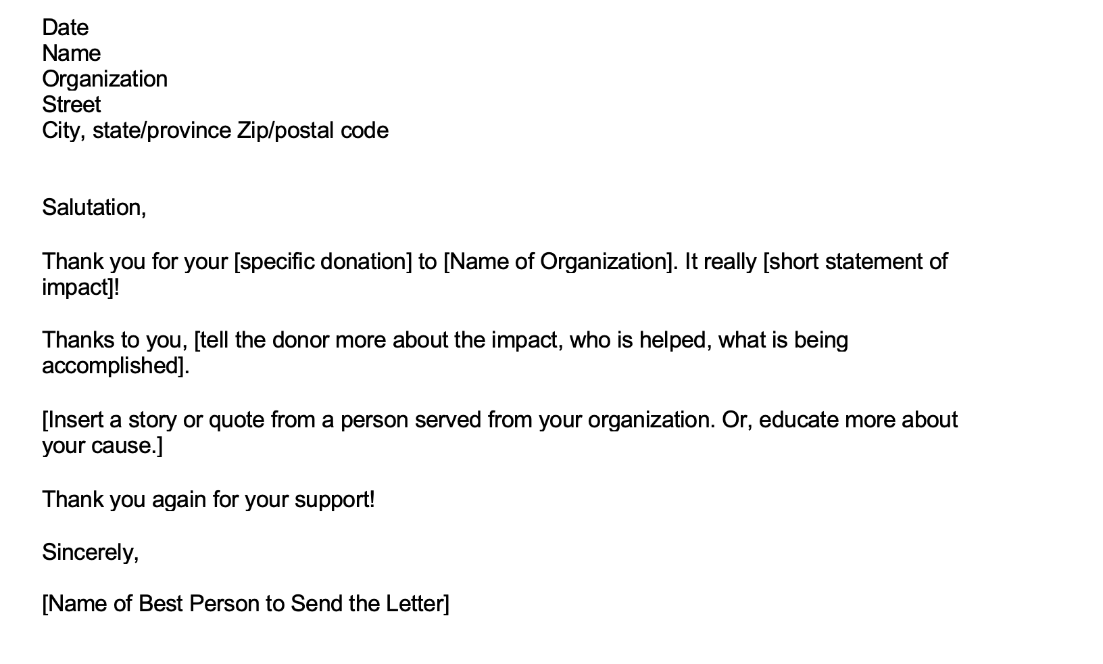

Sample:
Dear Luis,

Thank you for your donation to XYZ Nonprofit! It really makes a difference for the children in our community.

Thanks to you, kids have a safe place to go after school. Instead of going home alone while their families are at work, our kids are learning to play soccer and make art, forming friendships with peers and relationships with adult mentors, and improving their grades at our Homework Help Center.

Those three hours after the end of the school day can make a crucial difference in kids’ lives. Consider our friend Kim, age 10. Before joining our program, she’d walk home with her younger sister, and then lock the door until their mom got home. If she needed homework help, she had to wait. Thanks to your support, we were able to open a program at Kim’s school, and now, she and her sister go to XYZ Aftercare instead of their empty apartment.

Kim says it best: “XYZ Aftercare makes everyday fun! I took a coding class, and have my homework done before I go home.” Kim’s mom adds, “She learns so much! I never felt safe having the girls alone so long, but couldn’t afford any other options.” Thanks to you, Kim’s family doesn’t have to worry about how to pay for this care, and Kim and her sister are somewhere safe and enriching every day after school.

Thank you again for your ongoing support of our kids!

Sincerely,
Alice Agency Director

