Hello, Sarah!
It’s people like you who make what we do possible. Your donation of $250 on July 4, 2019, to our Save the Turtles! Campaign is greatly appreciated. So, let us be the first to say THANK YOU for being a part of our mission in saving the Sea Turtles!
Since 2013, we’ve been working tirelessly to ensure that the habitats for these beautiful creatures remain intact, as well as promoting their health and well-being to those who live in the communities around them.
Your amazing donation of $250 has a tax deductible amount of $200. Below, you will find a receipt for your records. Don’t worry, we’ll also send out a year-end tax summary in time for you to file early next year.
If you need to make any adjustments, you can follow the link below to manage your giving options with our donor management system, Kindful.
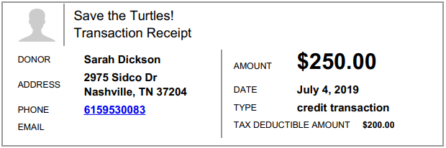
Thanks again!
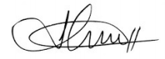
Jonathan
The Sea Turtle Foundation

