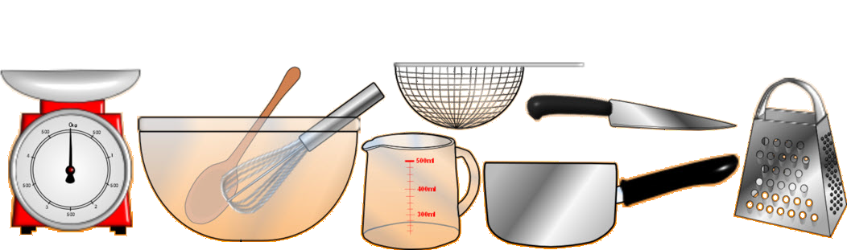
A recipe for
Ingredients
Equipment

Step-by-step instructions

Step-by-step instructions (continued)
How to serve
Picture of finished dish

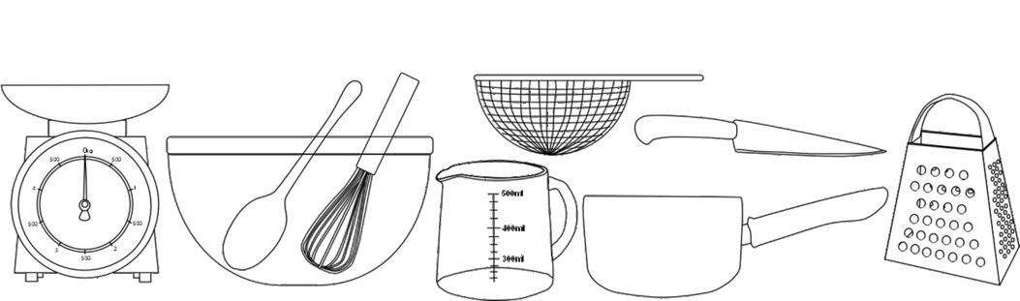
A recipe for
Ingredients
Equipment

Step-by-step instructions

Step-by-step instructions (continued)
How to serve
Picture of finished dish

