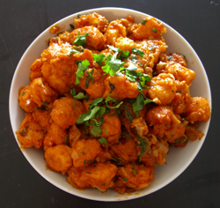

**Cookbook Template**

__________________________________________________________________________________________________________________________________________________________________________________________________________________________________________________________________________________________________________________________________________________________________________________________________________________________________________________________________________________________________________________

**Ingredients:**

**Method:**

_________________________________________________________________________________________________________________________________________________________________________________________________________________________________________________________________________________________________________________________________________________________________________________________________________________________________________________________________________________________________________________________________________________________________________________________________________________________________________________________________________________________________________________________________________________________________________________________________________________________________________________________________________________________________________________________________________________________________________________________________________________________________________________________________