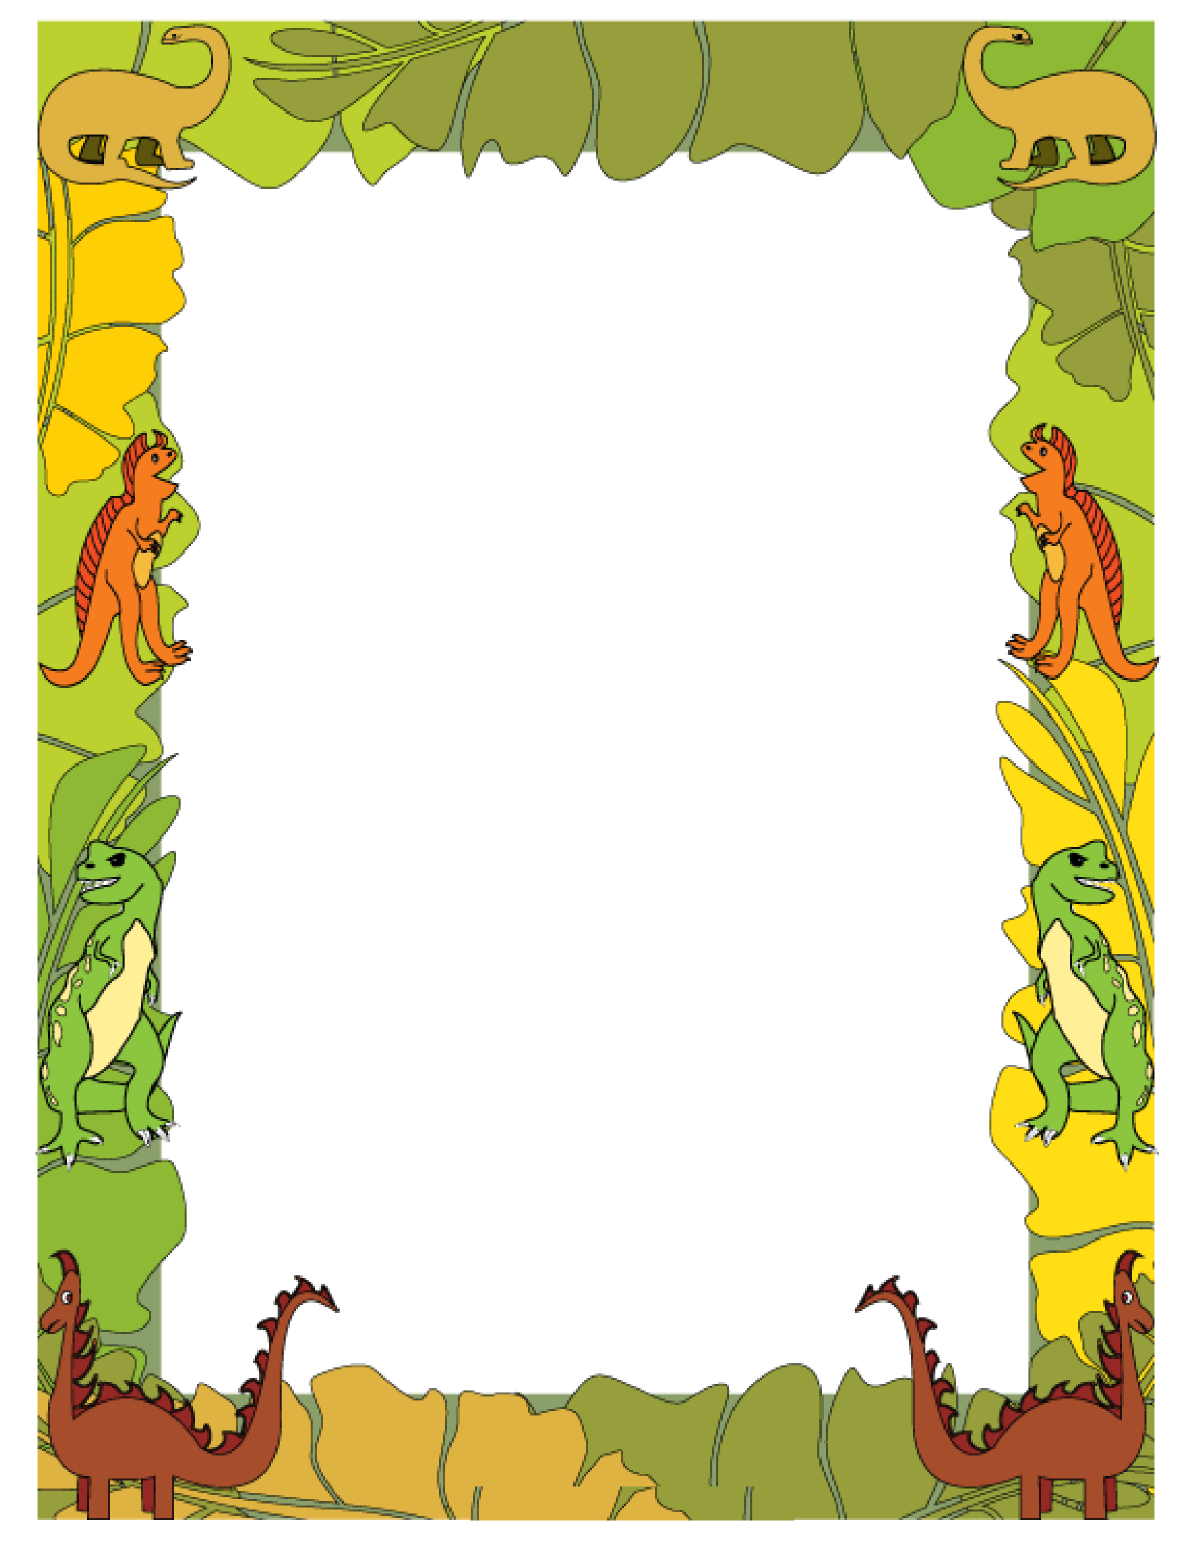

How did the story started? ___________________________________________________________________________

How did the story ended? ___________________________________________________________________________

Draw Setting then use details to explain

__________________________________________________________________________________________

My Book Report

