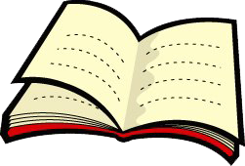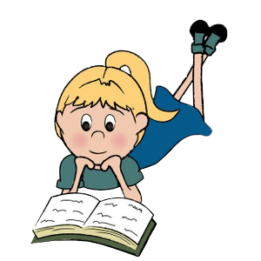

Characters: ________________________________________

Who is the story about???

A. Time: ______________________ B. Place: _________________________

When and where does story take place???

**INTRODUCTION:**

**BODY:**

Title:   
__________________________________________________________________________

Author:   
__________________________________________________________________________

Type of Book:   
__________________________________________________________________________

Name: _____________________ Date: _______________________

**MY BOOK REPORT!!!**