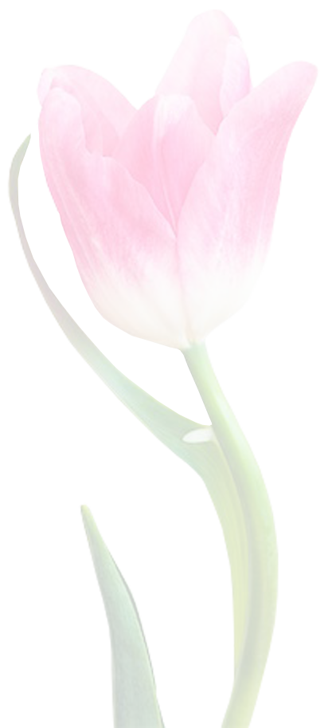

*Happy Birthday Card Template*

Dear ______________

***From*:** _____________

You are REMEMBERED today

In the HAPPIEST way and sent

WARM WISHES too, for a BIRTHDAY

That brings all your

FAVORITE THINGS and a year

That is DELIGHTFUL all through,

HAVE A WONDERFUL