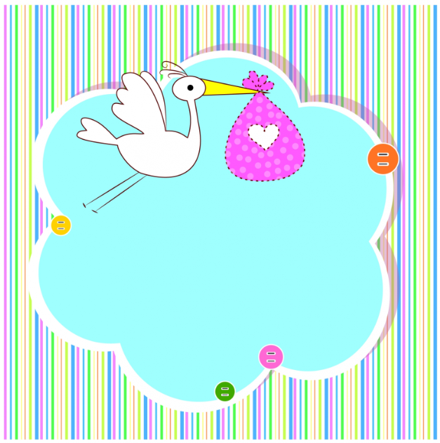

Bath Tub

Washcloths (4)

Hooded-Towel

Crib Sheets (2)

Crib

Crib Mattress

Crib Mattress Protector

Changing Pad *measure your changing table or dresser, pads come in different sizes

Changing Pad Cover

Changing Pad Liners

Nasal Aspirator

4-6 NB footed pajamas (our baby lived in these)

3 footed pajamas 0-3 months

3 footed pajamas 3-6 months

4-6 onsies *register for a combination of short and long sleeve, in 0-3 and 3-6 months, and consider what time of year your baby will be born

2-4 pants 0-3 months

2-4 pants 3-6 months

2 Hats (look for newborn sizes if possible)

2 Pairs of mittens

Socks 0-3 months (6 pack)

Socks 3-6 months (6 pack)

Burp Cloths

4 Swaddle Blankets. These can also be used as burp cloths, stroller blankets, etc. Velcro options are annoying but effective. We also liked the zipper version.

Baby Blanket. Consider something thick enough to lay on ground as play mat

Graco Modes Travel Stroller System

Pack and Play

Swing or Vibrating Chair

Motorola 2 Way Baby Audio Monitor

Sound Machine

Ergo Baby (plus infant insert)

Honest Diaper Backpack

Play Gym

Rearview Mirror

Diaper Genie or Trash Can (we went with one that uses regular trash bags)

Diaper Wipe Warmer

Breast Pump (contact your insurance, it might be free)

Bottle Starter Set (we went with glass bottles)

Bottle Drying Rack and stem

Natural Rubber Pacifiers

My Brest Friend Nursing Pillow

Newborn Lounger

2-4 pants 0-3 months

2-4 pants 3-6 months

2 Hats (look for newborn sizes if possible)

2 Pairs of mittens

Socks 0-3 months (6 pack)

Socks 3-6 months (6 pack)

Burp Cloths

4 Swaddle Blankets.

Baby Blanket.

Graco Modes Travel Stroller System

Pack and Play

Swing or Vibrating Chair

Motorola 2 Way Baby Audio Monitor

Sound Machine

Ergo Baby (plus infant insert)

Honest Diaper Backpack

Play Gym

Rearview Mirror

Diaper Genie or Trash Can

Diaper Wipe Warmer

Breast Pump (contact your insurance, it might be free)

Bottle Starter Set (we went with glass bottles)

Bottle Drying Rack and stem

Natural Rubber Pacifiers

My Brest Friend Nursing Pillow

Newborn Lounger

**Baby Registry Checklist**