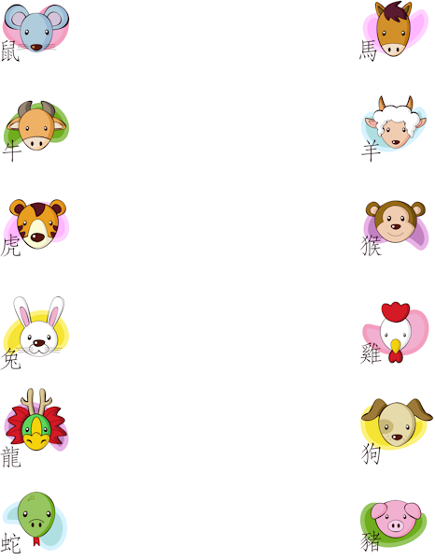
Natural Baby Registry Checklist

Layette
- Gentle Laundry Detergent – I used to make my own, but now I use Charlie’s Soap Laundry Liquid.

Nursery
- Co-sleeper or Play Yard with removable bassinet – I love Arm’s Reach Original
- Organic Cotton Waterproof PlayYard Pad
- 2 Fitted Organic Pack N Play Sheets
- 2-4 Receiving blankets
- Baby Monitor
- Teething Toys – Everybody loves Sophie!
- Cloth Grasping Toys
- Board Books
- Puppets – That just sounds like fun!

Changing
- Changing Table Pad – We have this one.
- 2-3 Changing Table Pad Covers
- 2 Washable Cloth Diaper Pail Liners
- 3 Dozen Organic Cloth Baby Wipes
- Container for Cloth Wipes
- Organic Cotton Cloth Diapers – 1 dozen per day for newborn size, buy as many as you need depending on how often you plan to wash.
- Diaper Covers – 3-4 per dozen diapers

Bath
- 6 Soft Washcloths
- 2 Organic Hooded Baby Towels

Feeding
- 4-8 Bibs
- 1-2 Dozen Organic Burp Cloths
- 6-8 pairs Washable Nursing Pads
- Nipple Cream
- Nursing Cover

Medicine Cabinet
- Baby Nail clippers or Blunt Scissors
- Thermometer
- Nasal Aspirator – Nosefrida Snotsucker Nasal Aspirator is amazing! I really like that it’s washable.
- Hyland’s Teething Tabs

Travel
- Car Seat – We’ve bought this carseat for both of our kids because it can be used rear facing up to 40 pounds and forward facing up to 65 pounds.
- Stroller – We have this stroller and love it. It’s the only stroller I need, it goes anywhere and is compact when folded.
- Diaper bag
- Changing Pad
- 2 Small Washable Wet Bags
- Wipes Holder
- Baby Carrier – I love the Boba 4G, Ergo Baby Carrier (Organic), and Moby Wrap.
- Sun Shade – for the car window

