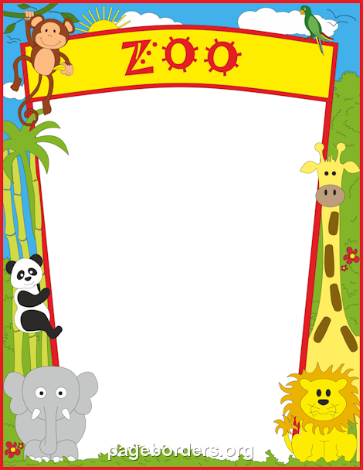

BABY REGISTRY CHECKLIST

Nursery
- Crib:.
- Crib Mattress:
- Crib Mattress Pad (2):
- Changing Pad:
- Changing Pad Cover (2):
- Rocker/Glider:
Bassinet, Moses basket, or Co-Sleeper:
- Swaddle Blankets (5) & Sleep Sacks (2-3).
Fitted Crib Sheets (2-3):
- Hamper and Storage Bins:
- Diaper Pail:

Feeding
- Bottles:
Bottle Brush:
- Sterilizer:
Pacifiers:
- Bottle Warmer:
Breast Pump & Accessories:
- Nursing Pillow & Cover:
High Chair:
- Bath + Potty
- Diapers, Creams, & Wipes:
Diaper Caddy:
- Infant Tub & Bath Set:
Washcloths & Hooded Towels:
- Faucet Cover & Bath Kneeler:
Baby Nail Clippers:
- Gear
- Car Seat & Stroller:
Bouncer/Lounger and Swing:
- Travel Crib:
- Health + Safety
- Baby Thermometer:
Humidifier:
- Baby Monitor:
- Noise Machine:
Nosefrida:

Clothing
- Other than a few inexpensive plain white cotton pieces (which I recommend the kimono type), you probably won’t need to register for any clothing items. This is everyone’s favorite item to pick out and gift you with at your shower!

