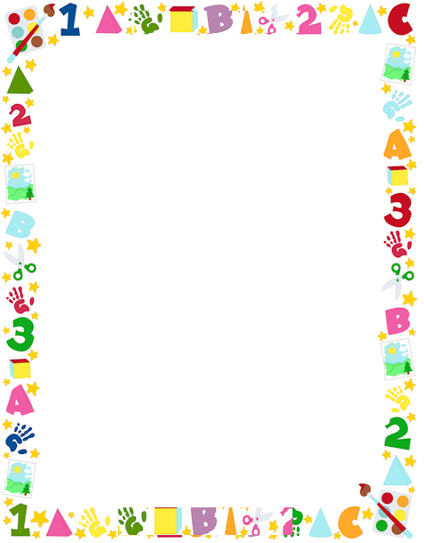
BABY REGISTRY CHECKLIST

ON THE MOVE
- Infant seat or Travel system
- Convertible car seat
- Carrier or Wrap
- Stroller
- Umbrella Stroller
- Jogging Stroller
- Diaper Bag

NURSING
- Breast pump
- Milk-storage bags
- Nursing pillow
- Nursing cover
- 2 to 4 nursing bras
- Nursing pads
- 10 burp cloths

BOTTLE FEEDING
- 8 bottles and nipples
- Bottle brush

FEEDING SOLIDS
- High chair
- Infant spoons and bowls
- Baby-food maker
- 2 to 4 bibs

PLAYTIME
- Swing
- Bouncy seat
- Play yard
- Activity seat
- Activity mat
- Mobile
- Toys

Moses basket or bassinet
- Crib
- Mattress
- 3 to 4 fitted crib sheets
- 2 waterproof mattress pads
- Glider
- Dresser
- Changing pad and cover
- Diaper pail and liners
- Monitor
- Cool-mist humidifier
- Hamper
- Clothing hangers
- Night light
- Tub
- 2 to 3 hooded baby towels
- Nail clippers
- Spout cover
- Thermometer
- Diaper rash ointment
- Baby lotion
- Baby shampoo
- Bath wash
- Sunscreen
- Baby toothbrush
- Nasal bulb syringe
- Diaper wipes
- First-aid kit
- Laundry detergent for Baby's skin
- 2 to 4 pacifiers (if using)

GETTING DRESSED
- 5 swaddle blankets
- 5 sleep sacks
- 4 to 6 sleepers
- 6 to 9 bodysuits
- 5 outfits
- 2 to 4 t-shirts
- 2 sweaters
- 2 to 4 hats
- 9 to 12 pairs of socks

