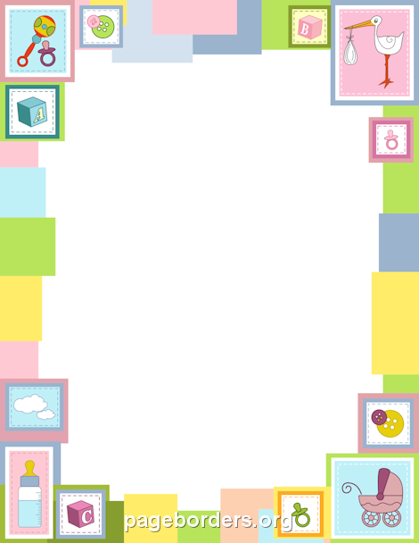
BABY REGISTRY CHECKLIST

Clothes
Wrap shirts...
Snap-up Pajamas...
Sleep Gowns...
Wrap Onesies...
Baby Mittens...
Booties & Socks
Shoes...
Hats...
Hamper & Laundry...
Sleeping & Soothing
Bassinet...
Crib...
Crib Bedding & Sheets...
Mattress...
Glider...
Sound Machine...
Baby Carriers & Slings
Rockers & Swings...
Pacifier...
Baby Monitor...
Space Heater...
Books on Sleep & Sleep Consulting
Playing and Lounging
Lounging...
Sitting...
Activity Gym...
*Jumperoo...
Rattles...
Stuffed Animals...

Feeding
Nursing Pillow..
Breast Pump...
Bottles
Bottle Rack...
Bibs...
Sterilizer...
Teething...
High Chair..
Books on Breast Feeding...
*Baby Food....
Pee & Poop
Changing Table...
Diapers & Wipes...
Diaper Disposable...
Creams...
Bath Time
Baby Tub...
Hooded Towel...
Bath Toiletries..
Bath Toys...
First Aid & Other Stuff
Toiletries...
Humidifier...
On the Go
Stroller
Carseat....
Mirror & Shade...
The Diaper Bag...

Swaddle Blankets...

