Baby Registry Checklist

Nursery
Essentials

Suggested Quantity
Crib

Crib mattress

Dresser

Changing table

Changing pad

Crib sheets

Waterproof crib pads

Wearable blankets

Swaddling blankets

Extras

Suggested Quantity
Glider rocker & ottoman

Crib mobile

Diaper stacker

Nursery storage

Armoire

Hamper

Bassinet

Bassinet sheets

Sheet savers

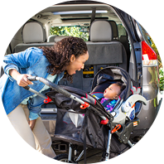

Car Seats & Travel
Essentials

Suggested Quantity
Infant car seat

Stroller

Baby carrier

Extras

Suggested Quantity

Car seat base

Car seat head support

Car seat toys

Sunshade

Baby mirror

Infant car seat cover

Convertible car seat

Diapering
Essentials

Diapers (boxes)

Baby wipes (boxes)

Diaper bag

Diaper ointment

Extras

Suggested Quantity
Diaper pail

Wipes warmer

Portable changing pad

Feeding & Nursing
Essentials

Suggested Quantity
High chair

Breast pump

Breast milk storage

Nursing pillow

Nursing stool

Baby bottles

Bottle nipples

Bibs

Burp cloths

Nursing Bras

Extras

Suggested Quantity
Breast care

Nursing cover up

Pacifiers

Bottle warmer

Bottle sterilizer

Teethers

Baby spoons

Bottle drying rack

Bottle brush

Bathing & Infant Care
Essentials

Suggested Quantity
Baby bathtub

Baby towels

Washcloths

Grooming kit

Nasal aspirator

Baby shampoo

Extras

Suggested Quantity
Bath toys

Humidifier

Air purifier

Baby lotion

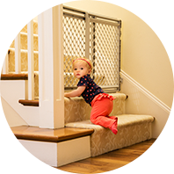

Health & Safety
Essentials

Suggested Quantity
Baby monitor

Thermometer

Safety gates

Outlet covers

Extras

Suggested Quantity
Infant acetaminophen

Infant gas relief drops

Teething relief

Clothing & Shoes
Essentials

Suggested Quantity
Onesies

Side snap shirts

Sleep 'N Play

Socks

Baby caps

Baby booties & socks

Extras

Suggested Quantity
Baby shoes

Baby shirts

Baby pants

Outfit sets

Activities & Toys
Essentials

Suggested Quantity
Infant swing

Bouncer

Playard

Toys

Books

Extras

Suggested Quantity
Activity gym

Walker

Jumper

Play mat

