THIS SERVICES AGREEMENT (the “Agreement”) is entered into on October 24, 2012 and is effective as of the Effective Date set forth below.

BETWEEN:

- Seadrill Management AS, a Norwegian company (the “Manager”), and

- Seadrill Partners LLC, a Marshall Islands limited liability company (the “Company”) (hereinafter jointly referred to as the “Parties” and, individually, as a “Party”).

WHEREAS, the Company wishes to engage the Manager to provide certain management and administrative support services to the Company on the terms set out herein.

NOW THEREFORE, the Parties have agreed as follows:

- APPOINTMENT AND EFFECTIVE DATE

  - The Company hereby confirms the appointment of the Manager to provide the general assistance and management services specified in this Agreement (the “Management Services”) to the Company and the subsidiaries of the Company listed on Schedule 1 to this Agreement, subject to the terms and conditions set forth in this Agreement, and the Manager accepts such appointment.

  - The effective date of this Agreement shall be June 29, 2012.

- BOARD OF DIRECTORS

  - The Manager shall always act in accordance with the direction of the Board of Directors of the Company (the “Board”) in providing the Management Services under this Agreement.

  - The Board may revoke any authorization granted to the Manager at any time in its sole discretion.

  - For clarity, no authority of the Board is delegated to the Manager by this Agreement. The Board of the Company expressly retains all authority granted to it pursuant to the Operating Agreement of the Company, dated June 28, 2012 (as the same may be amended, restated, modified or supplemented from time to time, the “Operating Agreement”).

- SERVICES

  - The Manager shall, throughout the term of this Agreement, provide such Management Services as the Company from time to time may specify.

  - The Manager may, at its discretion, sub-contract any of the services to be provided by the Manager hereunder to other companies within the Seadrill Group and/or other reputable companies as may be permitted hereunder from time to time, provided, that such company shall be sufficiently resourceful, experienced and qualified to fulfill the Manager’s duties and obligations hereunder, and, further, provided, that the Manager shall remain in all respects responsible for the due and proper performance by any such

1

subcontractor. The “ Seadrill Group” means Seadrill Limited or any subsidiary thereof, except the Company and its subsidiaries.

- Without prejudice to the generality of the foregoing, the Manager shall provide the following services to the Company:

  - Corporate Governance Services

The Manager shall assist the Company in the provision of general company secretarial services, including, but not limited to, keeping statutory books and records, convening meetings of the members of the Company, and meetings of the Boards of Directors and the shareholders of the subsidiaries of the Company and preparing adequate documentation for such meetings.

  - Company Records

    - The Manager shall be responsible for the safekeeping and professional filing of all original corporate documents of the Company and subsidiaries of the Company.

    - The Manager shall establish and maintain an adequate and accessible archive either (or both) in electronic form or physical form of all documents relevant to the Company’s business.

  - Treasury Services

Subject to the terms of any pooling arrangements which may exist in relation to the Company and its assets:

    - The Manager may be authorized to operate the Company’s bank accounts in accordance with such principles as the Board from time to time shall approve. Pursuant to such authorization, the Manager may be entitled to open bank accounts in the Company’s name and enter into account agreements and all such other contracts or agreements as shall be required by the banks and others for this purpose.

    - The Manager shall be authorized to collect all amounts due from third parties to the Company on the Company’s behalf and shall be responsible for the establishment and follow-up of efficient procedures for the purpose of collecting any overdue amounts.

    - The Manager shall arrange for the Company to settle its debts and accounts payable to third parties as such fall due, while pursuing a satisfactory solution of any dispute in relation thereto on the Company’s behalf.

    - The Manager shall settle all inter-company accounts between the Company and other companies in the Seadrill Group in accordance with such agreements and other documentation for payments as shall be in existence from time to time.

  - Financing

The Manager shall assist the Company in all matters relevant to the financing of the Company’s activities, including the identification of sources of potential

2

financing, negotiation of financing arrangements, and coordination of financing with other Seadrill Group companies for the benefit of the Company.

- Insurance

The Manager shall arrange to insure the vessels owned by the Company or its subsidiaries in accordance with the general guidelines and policies from time to time in force for coverage, insurers and terms for the insurance of vessels controlled by the Seadrill Group.

The Manager shall provide advice and assistance to the Company in filing and managing claims under all insurance policies procured for the vessels owned by the company or its subsidiaries (the “Vessels”) and the Company.

The Manager shall provide general advice and assistance to the Company in the procurement of other insurance as may be necessary or prudent in order to comply with legal or contractual requirements, or otherwise prudently insure the risks of the Company.

- Sale and Purchase of Assets

  - The Manager shall, in accordance with instructions from the Board, supervise the sale and purchase of assets on the Company’s behalf including the completion of such transactions.

  - In respect of any sale or purchase of an asset, the Manager shall provide assistance which shall include, but not be limited to, arranging the financing in the case of a purchase and, if necessary, renegotiating existing financing, and in the case of a sale or purchase, arranging other contractual agreements required by the transaction and the general completion of the specific transaction.

  - The Manager shall assist the Board in reviewing the market for sale and purchase of assets and providing the Company with recommendations in this respect. Any contracts related to a sale or purchase of an asset shall always be subject to the final approval of the Board.

- Accidents—Contingency Plans

The Manager shall assist the Company in handling all accidents involving its vessels. In particular, the Manager shall establish a crisis management procedure, shall assist the Company in the development of a local crisis management procedure, and shall provide other advice and assistance in connection with crisis response, including crisis communications assistance.

- Disputes

The Manager shall provide general advice and assistance in the prosecution or defense of any and all legal proceedings by or against the Company, on the Company’s behalf and follow up the same in accordance with such instructions as shall be provided to the Manager in this respect by the Company.

3

  - Marketing Services

The Manager shall provide advice and assistance in the marketing of the Vessels, including the identification of potential customers, identification of Vessels available for charter opportunities and preparation of bids.

  - General Administrative Services

The Manager shall cause certain of its officers as set forth on Schedule 2 to this Agreement and any of its additional officers or other employees as the Board may from time to time request (collectively, the “Manager’s Employees”) to perform as officers of the Company in the capacity as set forth on Schedule 2 or provide such general administrative services as may be required by the Company including accounting services, access to and consolidation of information in the Seadrill Group enterprise resource planning systems, and advice and assistance in the general administration and management of the business, with all of the duties of officers of the Company as provided by the Board of Directors of the Company pursuant to the terms of the Operating Agreement, subject to the sole direction of the Board of Directors of the Company and subject to Section 9 hereof.

- GENERAL CONDITIONS

- The Manager shall, in performing its duties hereunder, serve the Company in good faith. In exercising the powers and authorities hereby conferred on it, the Manager shall:

  - protect and promote the Company’s interests;

  - observe all applicable laws and regulations relevant to the Company’s activities; and

  - always act in accordance with good and professional management practice.

- The Manager shall be entitled to provide management services to other companies or entities.

Such entities can either be other companies in the Seadrill Group or third party entities.

- The Manager shall not afford preference to any vessel or company under its management but shall, so far as practicable, ensure a fair distribution of service to all such vessels and companies from time to time under its management.

The Manager shall, in the performance of its services, be entitled to take into consideration its overall responsibility in relation to all matters as may from time to time be entrusted to its management and in particular, but without prejudice to the generality of the foregoing, be entitled to allocate available supplies, manpower and services between its management assignments in such manner as in the prevailing circumstances the Manager in good faith considers to be fair and reasonable.

- All discounts, commissions and other benefits received by the Manager or any of its employees from third parties as a consequence of the provision of services hereunder shall be disclosed and credited to the Company.

4

  - The Company shall, at any time upon request, be provided with any information from the accounts and records of the Manager which is relevant and reasonably required for the performance of its obligations vis-à-vis the Company hereunder.

Such information shall be provided to such persons as shall be specifically authorized by the Company. Representatives of the Company’s auditor shall, in relation to the audit of the Company’s accounts, always be considered authorized.

  - The Manager shall, upon request, provide the Company with copies of all documents relevant to the Company in its possession and otherwise compile such facts and records on the basis of such documents as shall, from time to time, be requested by the Company.

- COMPENSATION

  - Each calendar quarter, the Company agrees to reimburse the Manager for all costs and expenses reasonably incurred by the Manager (the “Costs and Expenses”) in connection with the provision of the Management Services by the Manager to the Company for such calendar quarter.

  - The Company shall pay to the Manager a management fee equal to 5% of the Costs and Expenses for such calendar quarter (the “Management Fee”), subject to Section 5.4.

  - The Management Fee shall be payable by the Company on a quarterly basis. Within 30 days following the end of each calendar quarter, the Manager shall prepare a statement of Costs and Expenses incurred in providing the Management Services, setting forth the basis for calculation in such detail as reasonably required. The Manager shall then deliver an invoice to the Company for such costs together with the corresponding Management Fee. The Company shall pay undisputed charges within 30 days of receipt of the Manager’s invoice.

  - The Company shall pay the Management Fee to the Manager less any applicable withholding taxes.

- INDEMNITY

  - The Company agrees to indemnify and keep the Manager and its officers, employees, agents and sub-contractors, indemnified against any and all liabilities, costs, claims, demands, proceedings, charges, actions, suits or expenses of whatsoever kind or character that may be incurred or suffered by any of them howsoever arising (other than by reason of fraud, gross negligence or willful misconduct on the part of the Manager or any of its officers, employees, agents or sub-contractors,) in connection with the provisions of the Management Services or the performance of its duties hereunder.

The Manager shall not be required to take any legal action on behalf of the Company unless being fully indemnified (to its reasonable satisfaction) for all costs and liabilities likely to be incurred or suffered by it as a consequence thereof.

  - The indemnities provided by the Company hereunder shall cover all reasonable costs and expenses payable or incurred by the Manager in connection with any claims.

  - To the extent the Manager is entitled to claim any indemnity in respect of amounts paid or discharged by the Manager pursuant to this Agreement, these indemnities shall take effect as an obligation of the Company to reimburse the Manager for making such payment or effecting such discharge.

5

  - The indemnification provided by this clause shall not be deemed exclusive of any other rights to which those seeking indemnification may be entitled under any statute, agreement, the Operating Agreement of the Company or otherwise, and shall continue after the termination of this Agreement.

- NO CONSEQUENTIAL DAMAGES

  - NEITHER THE MANAGER NOR ANY OF ITS AFFILIATES SHALL BE LIABLE FOR

INDIRECT, INCIDENTAL OR CONSEQUENTIAL DAMAGES SUFFERED BY THE
COMPANY, OR FOR PUNITIVE DAMAGES, WITH RESPECT TO ANY TERM OR THE
SUBJECT MATTER OF THIS AGREEMENT, EVEN IF INFORMED OF THE
POSSIBILITY THEREOF IN ADVANCE. THIS LIMITATION APPLIES TO ALL CAUSES
OF ACTION, INCLUDING, WITHOUT LIMITATION, BREACH OF CONTRACT, BREACH
OF WARRANTY, NEGLIGENCE, STRICT LIABILITY, FRAUD, MISREPRESENTATION
AND OTHER TORTS.

- CONFIDENTIALITY

  - All Confidential Information furnished to, or developed by, the Manager or any of its employees, directors or sub-contractors pursuant to this Agreement shall be the property of the Company, and shall be kept confidential by the Manager, both during and after the term of this Agreement.

    - For the purpose of this clause, “Confidential Information” shall mean information relating to the business of the Company as well as all know-how of which the Manager becomes aware or generates in the course of or in connection with the performance of its obligations hereunder.

    - The provisions of this clause shall not apply to Confidential Information which:

      - is required to be disclosed by law or court order; or

      - has become public knowledge otherwise than as a result of the conduct of the Manager.

    - The Company shall be entitled to any equitable remedy available at law or equity, including specific performance, against a breach by the Manager of this obligation. The Manager shall not resist such application for relief on the basis that the Company has an adequate remedy at law, and the Manager shall waive any requirement for the securing or posting of any bond in connection with such remedy.

  - All Confidential Information furnished to, or developed by, the Company or any of its employees, directors or sub-contractors pursuant to this Agreement shall be the property of the Manager, and shall be kept confidential by the Company.

    - For the purpose of this clause, “Confidential Information” shall mean information relating to the business of the Manager as well as all know-how of which the Company becomes aware or generates in the course of or in connection with the performance of its obligations hereunder, both during and after the term of this Agreement.

    - The provisions of this clause shall not apply to Confidential Information which:

      - is required to be disclosed by law or court order; or

6

      - has become public knowledge otherwise than as a result of the conduct of the Company.

    - The Manager shall be entitled to any equitable remedy available at law or equity, including specific performance, against a breach by the Company of this obligation.

- TERM AND TERMINATION

  - This Agreement shall have an initial term of five (5) years unless terminated:

    - by the Board or pursuant to Section 10.1 hereof upon 90 days’ written notice for any reason in its sole discretion; or

    - by the Manager upon 90 days’ written notice if:

      - there is a Change of Control of the Company or Seadrill Member LLC;

    - a receiver is appointed for all or substantially all of the property of the Company;

    - an order is made to wind up the Company;

    - a final judgment, order or decree which materially and adversely affects the ability of the Company to perform under this Agreement shall have been obtained or entered against the Company, and such judgment, order or decree shall not have been vacated, discharged or stayed; or

    - the Company makes a general assignment for the benefit of its creditors, files a petition in bankruptcy or for liquidation, is adjudged insolvent or bankrupt, commences any proceeding for a reorganization or arrangement of debts, dissolution or liquidation.

  - Notwithstanding the foregoing, the arrangement with respect to the provision of the Management Services by any or all of the Manager’s employees may be terminated at any time with respect to any or all of such Manager’s employees by the Board in its sole discretion. Such Management Services shall terminate immediately upon delivery by the Board of written notice to the Manager. The termination of the Management Services with respect to any or all of the Manager’s employees shall not constitute a termination of the other provisions of this Agreement.

- DEFAULT

  - Notwithstanding Section 9.1(a), if the Manager shall, by any act or omission, be in breach of any material obligation under this Agreement and such breach shall continue for a period of 14 days after written notice thereof has been given by the Company to the Manager, the Company shall have the right to terminate this Agreement with immediate effect by notice to the Manager.

The right to terminate this Agreement shall be in addition to and without prejudice to any other rights which the Company may have against the Manager hereunder.

7

- FORCE MAJEURE

Neither Party shall incur liability of any kind or nature whatsoever in relation to the other Party in the event of a failure to perform any of its obligations hereunder directly or indirectly caused by circumstances beyond the relevant Party’s reasonable control, such as war or war-like activities, government orders, riots, civil commotion, strike, lock-out or similar actions, an act of God, peril of the sea or any other similar cause.

- NOTICES

All correspondence or notices required or permitted to be given under this Agreement shall be given in English and sent by mail, telefax, electronic mail or delivered by hand at the following addresses:

If to the Company:

Seadrill Partners LLC 13th Floor

One America Square 17 Crosswall London

EC3N 2LB United Kingdom
Attn. Chief Executive Officer If to the Manager:
Seadrill Management AS Løkkeveien 111

P.O. Box 110
4001 Stavanger, Norway Telefax: + 47 51 30 96 88 Attn. Managing Director

or such other address or telefax number as either Party may designate to the other Party in writing.

- MISCELLANEOUS

  - The Manager shall not be entitled to assign its rights and/or obligations under this Agreement unless the prior written consent of the Company has been obtained. The Manager may freely subcontract or sub-license this Agreement, so long as the Manager remains liable for performance of the Management Services and its obligations under this Agreement.

  - The relationship between the parties hereto is that of an independent contractor. Nothing in this Agreement shall be deemed to constitute a partnership between the Parties.

  - Upon termination of this Agreement, the Manager shall surrender to the Company any and all books, records, documents and other property in the possession or control of the Manager relating to this Agreement and to the business, finance, technology, trademark or affairs of the Company and its subsidiaries, and except as required by law, shall not retain any copies of the same.

8

  - No term of this Agreement is enforceable by a person who is not a Party to it, except by the affiliates of the Company and/or the Manager.

  - This Agreement shall not be amended, supplemented or modified save by written agreement signed by or on behalf of the Parties.

  - The failure of either party to enforce any term of this Agreement shall not act as a waiver. Any waiver must be specifically stated as such in writing.

  - If any provision herein is held to be void or unenforceable, the validity and enforceability of the remaining provisions herein shall remain unaffected and enforceable.

  - This Agreement shall be binding upon and inure to the benefit of the affiliates of the Company and/or the Manager.

  - This Agreement may be executed in one or more signed counterparts, facsimile or otherwise, which shall together form one instrument.

- GOVERNING LAW AND ARBITRATION

  - This Agreement shall be governed by and interpreted in accordance with Norwegian law.

  - Any dispute, controversy or claim arising out of or relating to this Agreement, or the breach, termination or invalidity thereof, shall be settled by arbitration in accordance with the provisions of the Norwegian Arbitration Act 2004.

[SIGNATURE PAGE FOLLOWS]

9

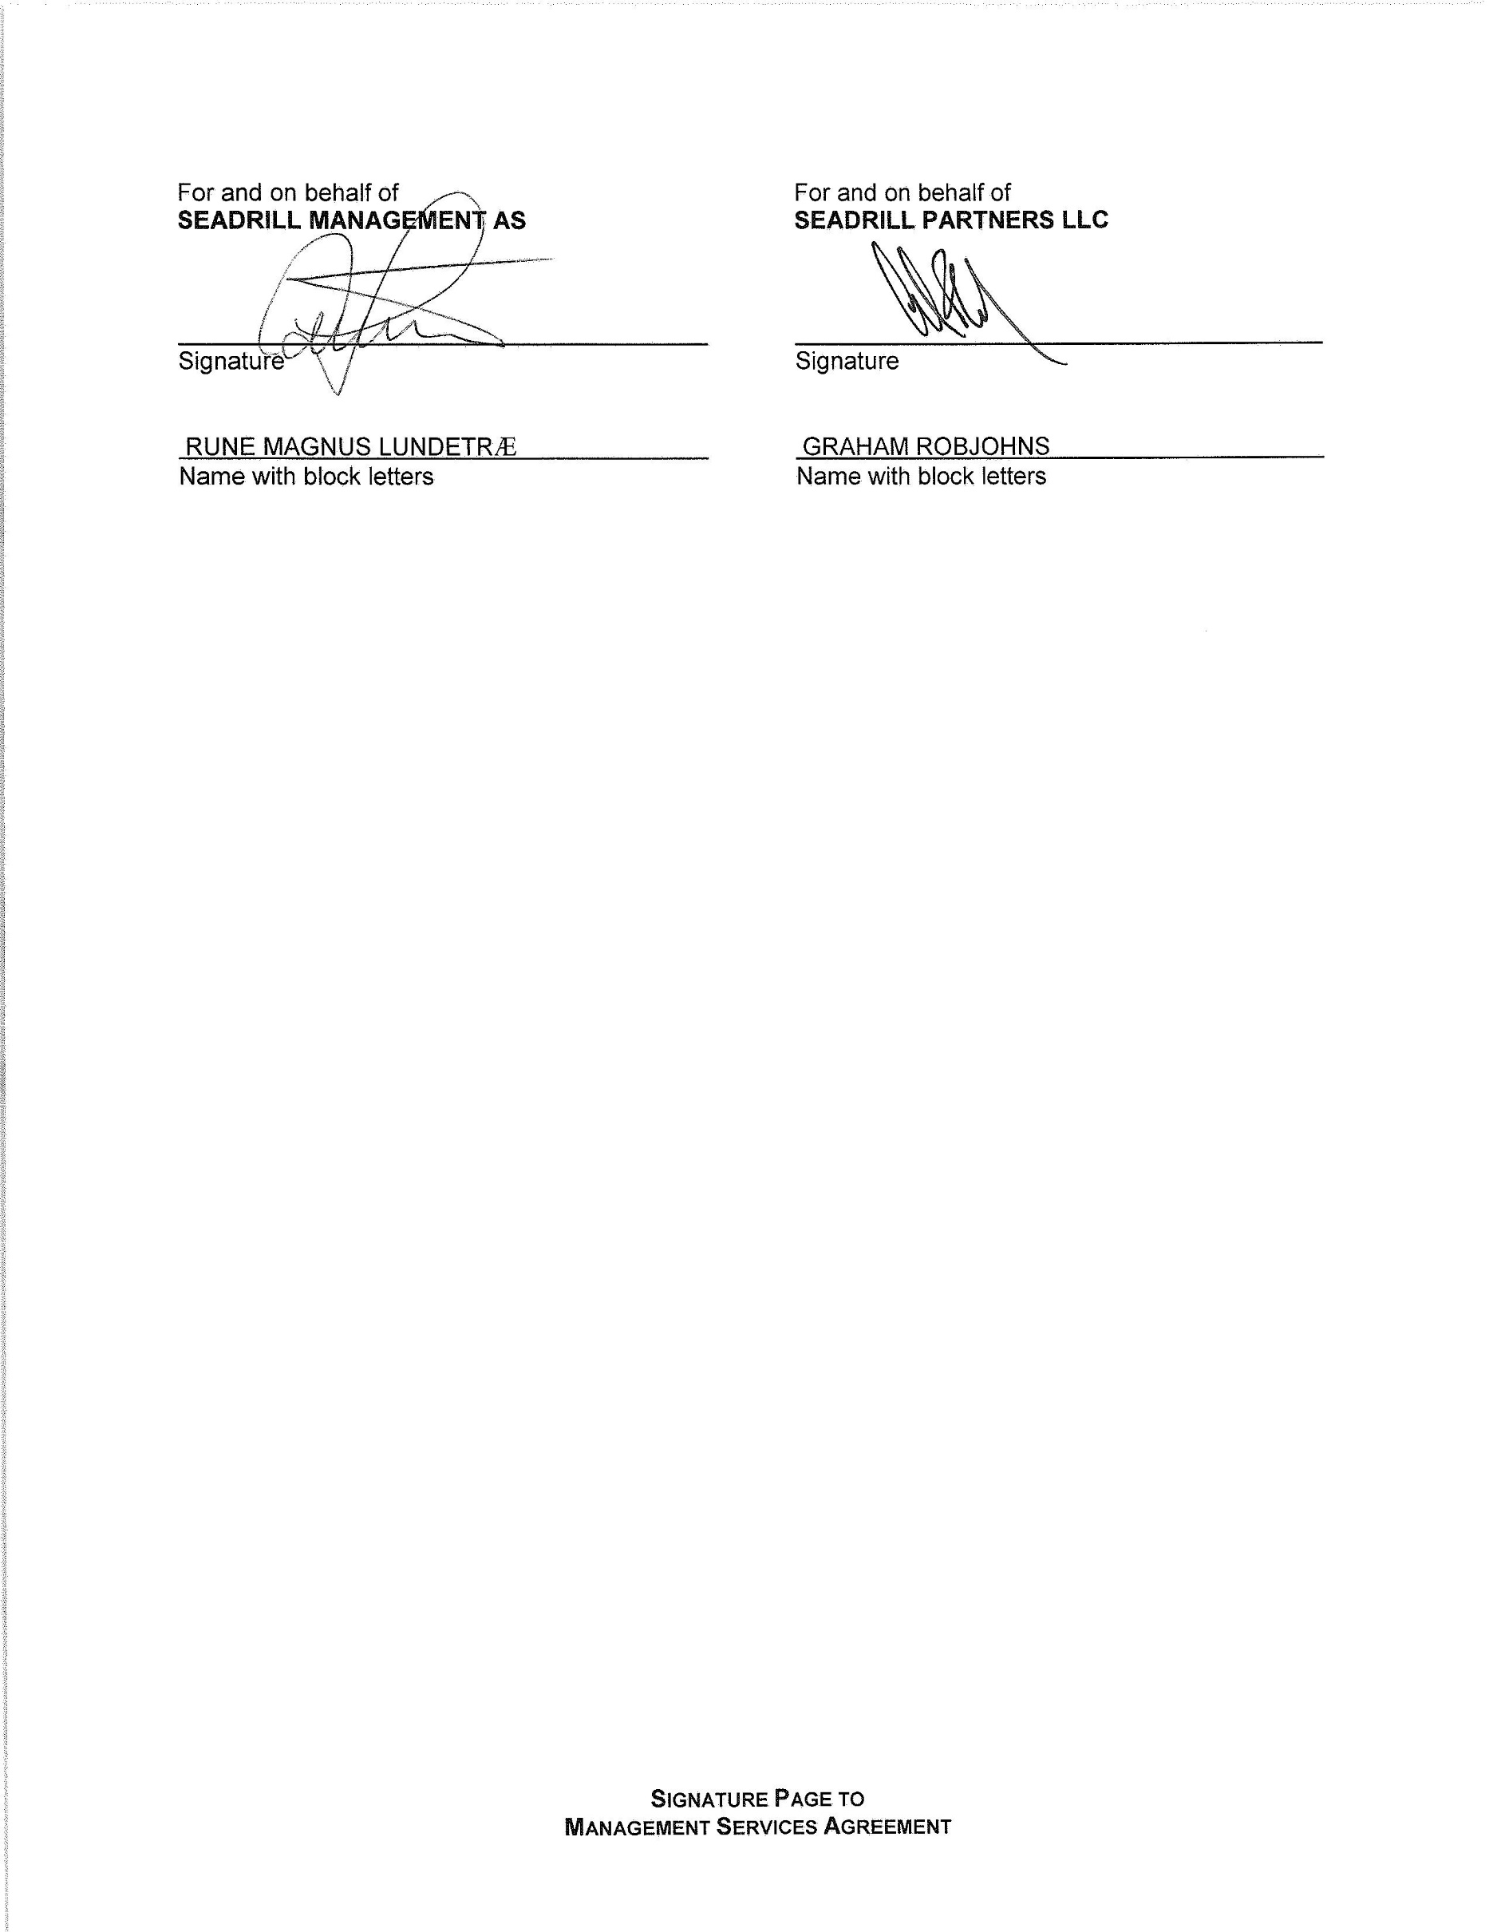
SCHEDULE 1

SUBSIDIARIES

Subsidiary Jurisdiction of Formation

Seadrill Operating GP LLC Republic of the Marshall Islands
Seadrill Operating LP Republic of the Marshall Islands
Seadrill Opco Sub Ltd. Republic of the Marshall Islands
Seadrill Capricorn Holdings LLC Republic of the Marshall Islands
Seadrill Capricorn Ltd. United Kingdom
Seadrill US Gulf LLC Delaware
Seadrill Mobile Units (Nigeria) Ltd. Nigeria
Seadrill Deepwater Drillship Ltd. Cayman Islands
Seadrill Canada Ltd. Newfoundland
Seadrill China Operations Ltd. Bermuda
Seadrill Vencedor Ltd. Bermuda

Schedule 1

SCHEDULE 2

INITIAL MANAGER’S EMPLOYEES

Name Position at the Manager Position at the Company

Rune Magnus Lundetrӕ Chief Financial Officer and Senior Chief Financial Officer

Vice President

Schedule 2

