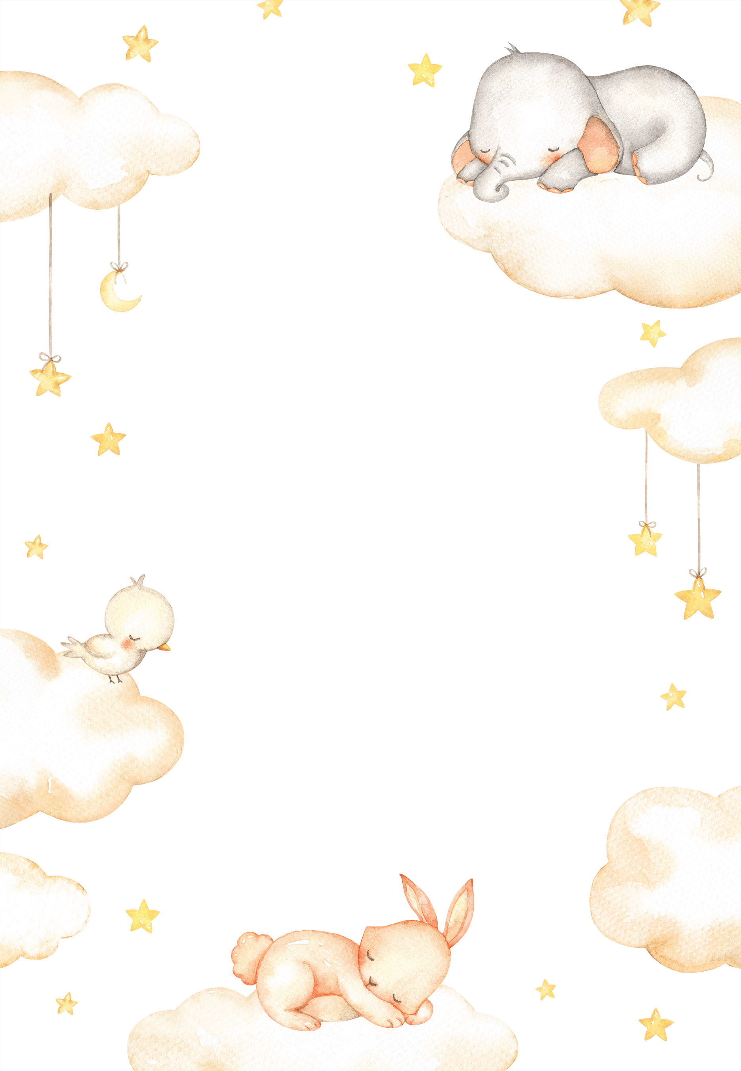
NEWBORN ESSENTIALS CHECKLIST

Clothing |  | Others
- Bodysuits (6) |  | - Thermometer – an absolute essential
- Night gowns (2) |  | - White noise
- Zip-up Onesies (3-4) |  | - Wrap/Front Pack
- Merino socks and/or booties |  | - Soft face cloths
- Cardigans (2) |  | - Old style cloth nappies for spills
- Hats (2) |  | - Wet Bag
- Bodysuits (6) |  | - Safe Capsule/
- Night gowns (2) |  | - Baby nail clippers
- Zip-up Onesies (3-4) |  | - Thermometer – an absolute essential
- Merino socks and/or booties |  | Tools & information
- Cardigans (2) |  | - White Noise CD or Machine
Swaddling wraps & Sleeping Bag |  | - Sleep advice & know-how
- 3 x fitted swaddling wraps |  | - Black-out blinds
- Muslin wraps (for summer baby) |  | - Comforter
- Swaddle Blanket |  | - Cool Mist Humidifier
- 3-Seasons Sleeping Bag |  | - Baby Monitor
- Swaddling wraps & Sleeping Bag |  | Clothing
- 3 x fitted swaddling wraps |  | - 6 x bodysuits
- Muslin wraps (for summer baby) |  | - 2 x nightgowns
- Swaddle Blanket |  | - 3-4 x zip-up onesies

