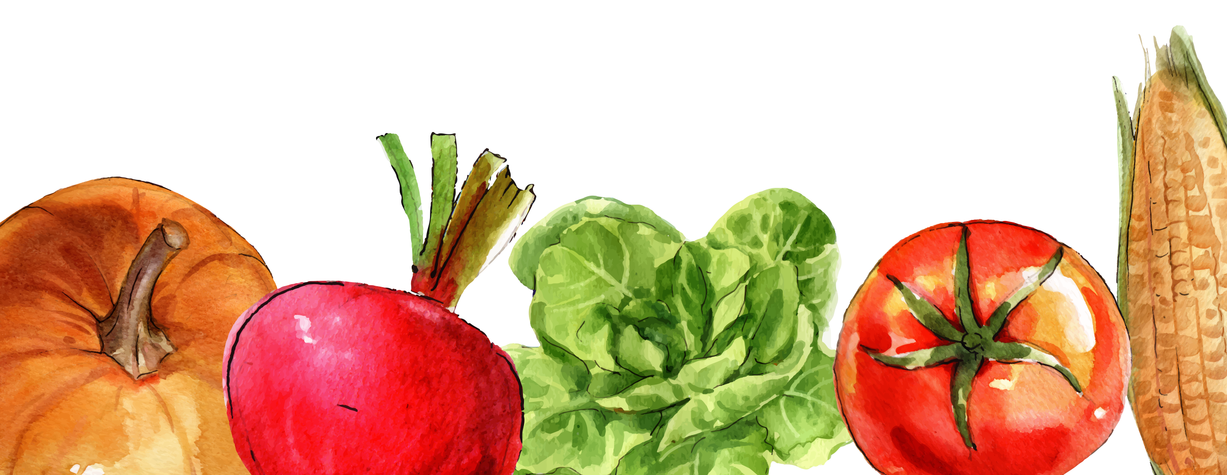

v

v

v

v

v

v

v

v

v

v

v

v

v

v

v

v

v

v

v

v

v

v

v

v

Other

Home Supplies

Toiletries

v

v

v

v

v

v

v

v

v

v

v

v

v

v

v

v

v

v

v

v

v

v

v

v

Dairy / Deli

Canned Goods

Condiments / Sauce

v

v

v

v

v

v

v

v

Grains

v

v

v

v

v

v

v

v

Meat / Poultry

v

v

v

v

v

v

v

v

Fruits / Vegetables

