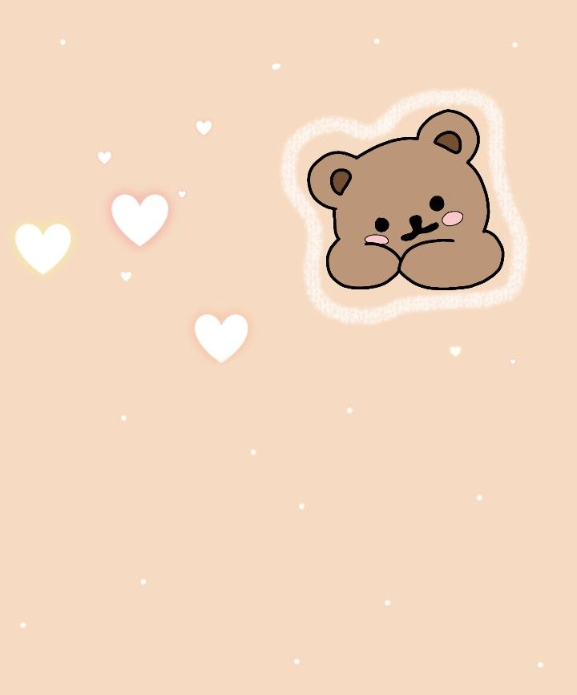
NEWBORN ESSENTIALS CHECKLIST

Baby Essentials |  | Nursery Furniture
- Nursery furniture and gear |  | - Crib
- Baby linens |  | - Crib mattress
- Babyproofing gear |  | - Changing table
- Feeding gear |  | - Bassinet
- Diaper essentials |  | - Rocking chair or glider
- Hygiene and grooming essentials |  | - Humidifier or vaporizer
- Baby clothes |  | - Dresser/chest
- Travel gear |  | - Hamper
- Entertainment |  | - Changing table
Babyproofing Gear |  | Breastfeeding Gear
- Gates at the top and bottom of all stairs |  | - Nursing pillow
- Cabinet latches |  | - 2 or 3 nursing bras
- Drawer latches |  | - 2 or 3 boxes of nursing pads
- Outlet covers |  | - Freezer-safe breast
- Furniture anchors |  | - 6 or more burp cloths
- Gates at the top and bottom of all stairs |  | - Nursing pillow
- Cabinet latches |  | - 2 or 3 nursing bras
- Drawer latches |  | - 2 or 3 boxes of nursing pads
- Outlet covers |  | - Freezer-safe breast
- Outlet covers |  | - 6 or more burp cloths

