RESIDENTIAL LEASE AGREEMENT

- Parties.
This Residential Lease Agreement (“Agreement”) made this 24th day of January 2030 is between:
Landlord Name: Jake Todd with a mailing address of:
123 Property Manager Rd, San Diego, California 91932 (“Landlord”), AND
Tenant Name(s): Benjamin Jameson (“Tenant(s)”).
Landlord and Tenant are each collectively referred to as the "Parties."

- Property.

The Landlord agrees to lease the described property to the Tenant:
Address: 123 Tenant St, San Diego, California 91932 (“Premises”).
Residence Type: ☐ Single-family ☐ Apartment ☐ Condominium ☐ Other: ____________.
- Term.

The Agreement shall begin on the 1st day of February , 2030 and end on the 1st day of February , 2031 .

- RENT.

The Tenant shall pay the Landlord in equal monthly installments of $1400
(“Rent”). The Rent shall be due on the 1 of every month (“Due Date”) and paid
under the following instructions:
Paid via check to .

- SECURITY DEPOSIT.

The Tenant (check one):

☐ Shall deposit with the Landlord the sum of $1400 as security for any damage caused to the Premises during the Term. Such deposit shall be returned to the Tenant, less any itemized deductions, within 21 days after the end of the Term.

☐ Shall NOT be required to pay a security deposit

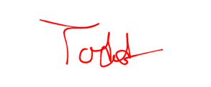
- SIGNATURES.
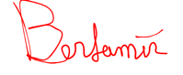
Landlord’s Signature: Date: 01/24/2030
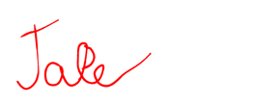
Printed Name __________________________________
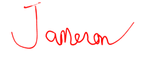
Tenant Signature: ______ Date: 01/24/2030
Printed Name: Benjamin Jameson

Tenant Signature: Date:
Printed Name:

